**MongoDB Exercise 2**

Create database **“student_data”** & collection **“student”.**

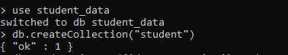

**Insert documents :**

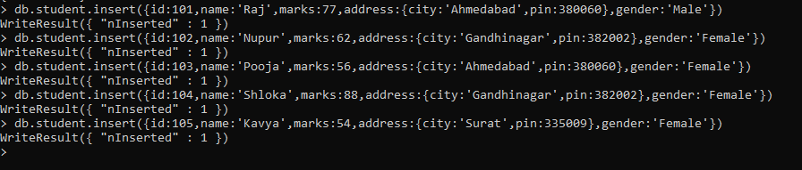



**Find out total number of students for each marks. :-**

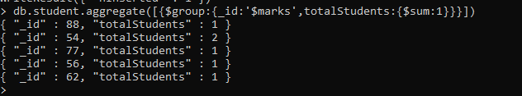

**Find out student count for each city :-**

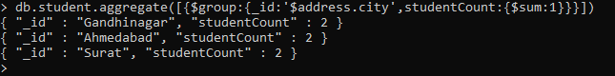

**Find out sum of all students marks :-**



**Find out student count who got > 60 marks :-**



**MapReduce :**

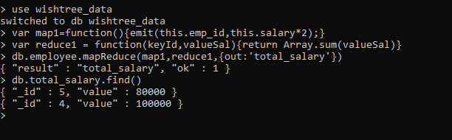

**Create Index :-**

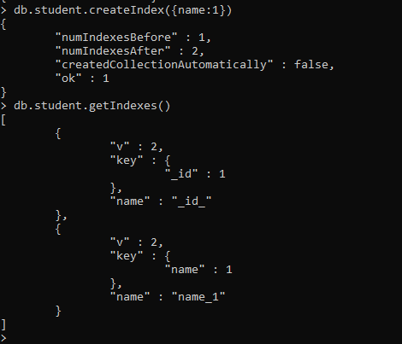

**Drop Index :-**



**MongoDB Compass**

**Insert data :-**

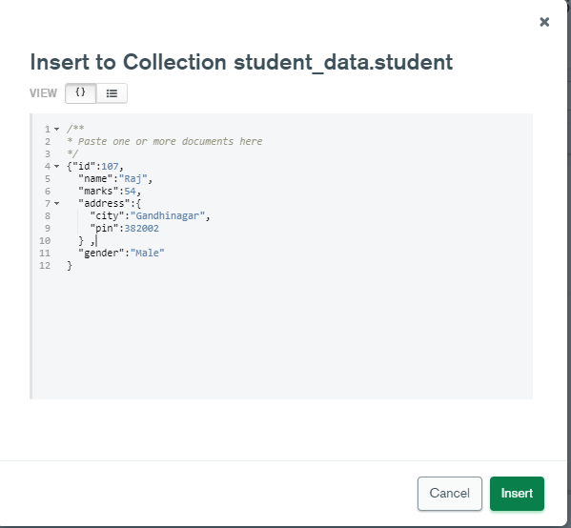

**Data is successfully inserted :-**

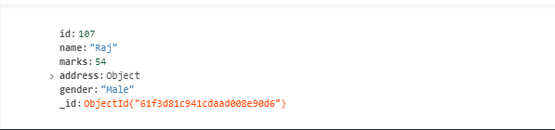

**Export data :-**

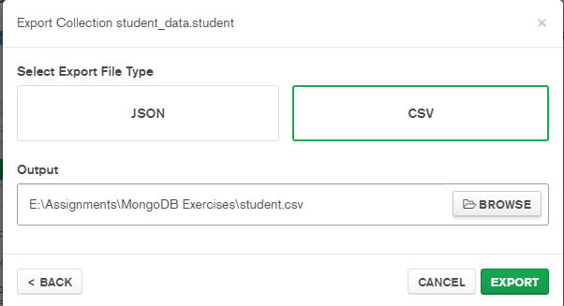

**Show csv :-**

